**EXPERIMENT 7**

**DQL COMMANDS (COLLEGE SCHEMA)**

**Aim:**

1)Display student id and marks from the student table.

2)Display faculty id and name from the faculty table.

3)Display who got grade A.

4)Display whose marks are less than 50.

5)Display the female students whose marks are between 50 to 60.

6)Delete the failed students.

7)Display activity id and name using object.

8)Display student id, faculty id using course name condition with object.

9)Select department name starting from ‘c’ and faculty name ending with ‘ ’.

10)Select activity having characters between ‘ck’.

11)Group by faculty id and display.

12)Display the students list whose grade is A using having.

13)Display the faculty list who are teaching PPS.

14)Apply aggregate functions in student marks - max, min, sum, count, avg.

**Code:**

select a.activity_id,a.activity_name from activity a;

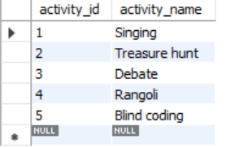

select s.student_id,f.faculty_id from student s,faculty f where s.course=f.course;

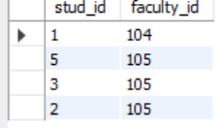

select department_name,faculty_name from department,faculty where department_name like 'C%' and faculty_name like 'A%';

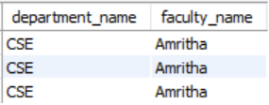

select * from activity where activity_name like '%i%';

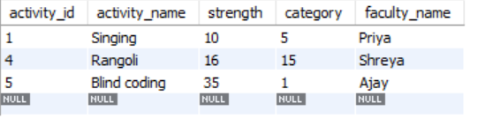

select faculty_id from faculty group by faculty_id;

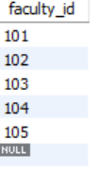

select student_name from student group by grade having grade='A';

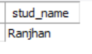

select faculty_name from faculty group by course having course='C';

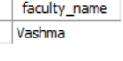

select avg(marks), min(marks),max(marks),sum(marks),count(marks) from student;

